Power Query editor

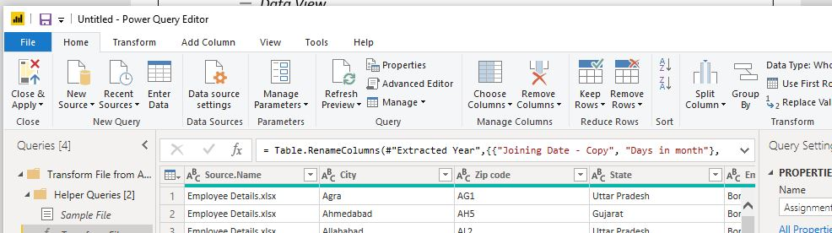

Report view

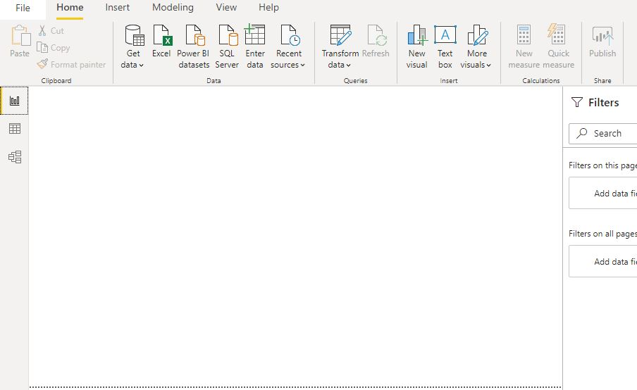

Model view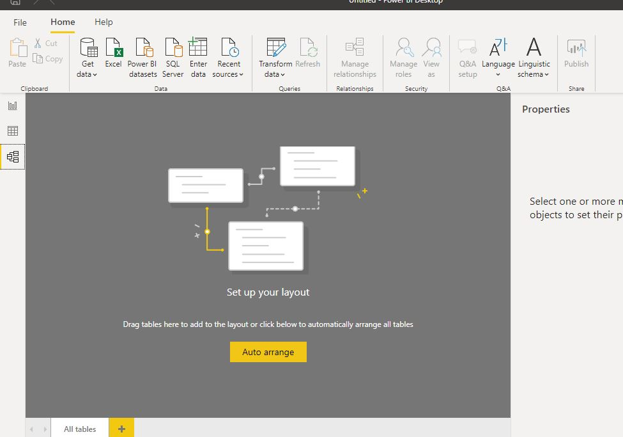

Data View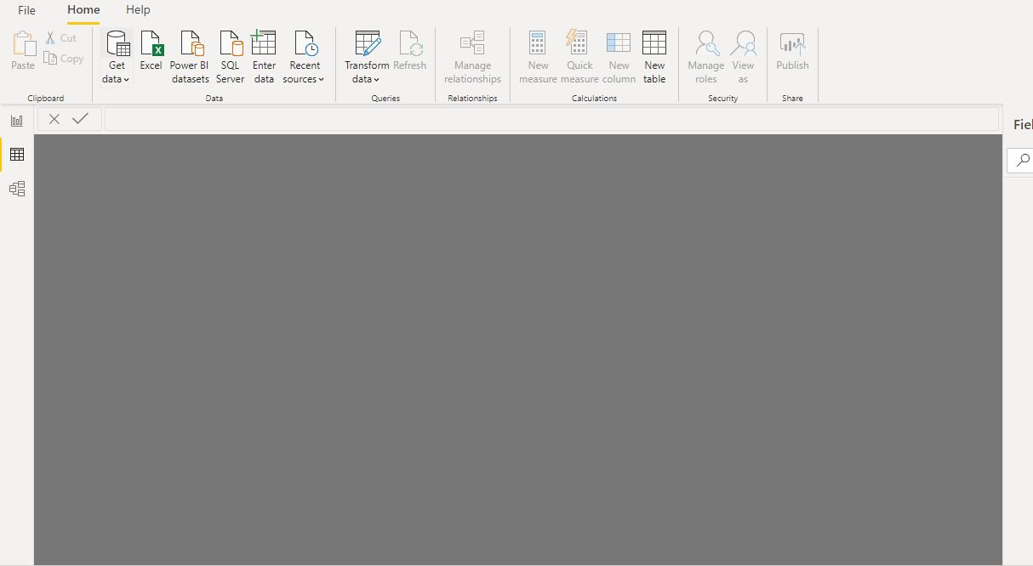

Power Bi desktop

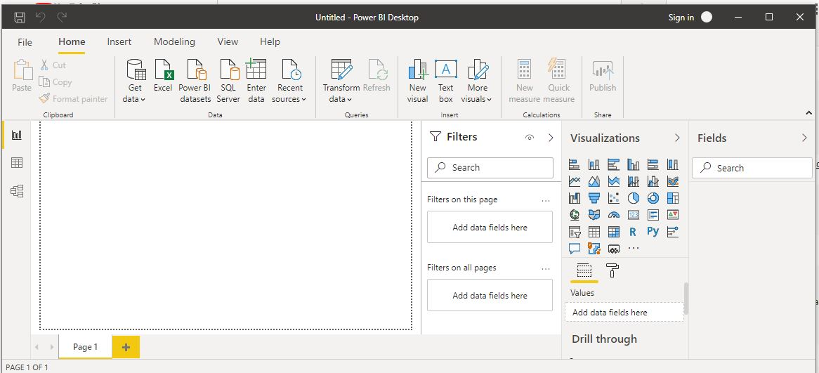

Advance editor

|  |  |  |  |  |
| --- | --- | --- | --- | --- |
|  | Price |  |  |  |
| Desktop |  |  |  |  |
| Pro |  |  |  |  |
| Premium |  |  |  |  |